 |  | Mr. Greenhouse  6th Grade Science
Bears, welcome to the 2016-2017 school year! I am excited to have you in my class at James Bowie Middle School. Listed below are some of the expectations and procedures for 6th grade science at JBMS. Please familiarize yourself with these procedures and share with your parents/guardians. Also read, sign, and return the Safety Contract by Monday, August 29th.
Welcome to  6th grade! | Supplies Needed:
Welcome to your 6th grade year at Bowie! You will enjoy the increased activities and freedoms associated with 6th grade. You will also become aware that your attitude and study habits are crucial to your success this 1st year in middle school. | The following supplies should be brought to class everyday by Friday:  - Folder/Binder for loose handouts (can be shared with another class)  - 1 3-subject Spiral Notebook  - 1 Composition notebook  - Continuous supply of notebook paper  - Pencils  - Pens (blue or black ink/ a red pen)  - School Planner(provided by the school)  - Supply bag – crayons, markers, scissors, glue stick or tape  See below for your class period assigned supply to bring in by Friday….  - 1st – 2 boxes of tissue  - 3rd – 2 packages of notebook paper  - 4th – 2 large glue sticks or 4 small glue sticks  - 5th – 1 box of markers  - 6th – 2 packages of index cards  - 7th – 1 box of crayons  Other classroom materials needed if interested in donating  - Magazines  - Hand Sanitizer  - Sandwich size Ziploc baggies
About your Teacher
I graduated from the Southern University A&M with a Bachelor’s degree in Childhood Development and also a Master’s Degree in Counseling from Prairie View University.  Parent communication is very important to me. Please contact me with questions or concerns by email at  Julius.Greenhouse@fortbendisd.com.  Please allow at least 24 hours for a response.  *Parents – Please check that your phone numbers and e-mail address are up to date in Skyward. This is how I am able to look up information to communicate with you. Thanks! | Guidelines for Success
Believe in yourself
Exceed expectations
Always come prepared to learn
Respect yourself and your classmates
Set an example

 | Grading Policy
  - Major Grades – 50% of the nine week average. There are at least 3 major grades taken for each nine week period. Examples: Chapter/Unit tests, Projects, Complex Labs
- Daily Grades – 50% of the nine week average. There are at least 11 daily grades taken for each nine week period. Examples: Homework, Quizzes, Simple Labs, Participation

 | Homework Policy
- Completing your homework is a class expectation. It is necessary for your success this year.
- Assignments are posted on the board and on my webpage weekly. Students are expected to copy homework assignments into their school-provided planner.
- Homework is due at the beginning of the period unless otherwise stated.
- Homework is due on the second day of the assigned date. (Ex. If the homework is assigned on Monday the homework is due on Wednesday morning)
- Please note if a class work assignment is taken home to finish it is due the next day or the late policy will be enforced.
Attendance Policy | Tutorials
Attendance Policy | Tutorials are offered on Thursday morning at 8:15, however if a different day or time is needed they can be scheduled on an as-needed basis. My goal is to see each of my students succeed and I am willing to provide extra assistance if you ask me for help. Tutorials are open to all students who need additional help on new concepts or assignments.
- If a student is absent for any reason, the student’s responsibility is to get their missed assignments from the Absent Work Folders. Students will be given 1 day for each day absent to complete the missed work.
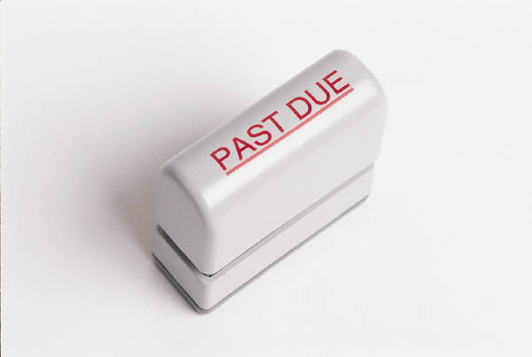
- Work assigned before a student was absent is due the day the student returns or it is considered late.

 | Consequences for Misbehavior
Each student is expected to conduct him/herself in an appropriate manner at all times. If laboratory safety or classroom rules are violated, the following consequences will be enforced:

- Verbal Warning
- Written Warning
- Parent contact
- Morning Detention and sent to Office with Discipline Referral
*This is a general guideline for minor concerns. Different sequences might occur depending on severity of the offense and aligning with school procedures.

Late Work Policy | Cheating Policy
10 points off for every day late.  Ex. -10 for 1 day late  -20 for 2 days late  Note – Late work is not excepted after 5 days late | Cheating in any form is unacceptable and will not be tolerated in this class. Examples of cheating include: copying or “borrowing” from another student, seeking or accepting unauthorized assistance on tests or assignments. Consequences for cheating will result in a zero for that test or assignment and parent contact. Multiple offenses will require disciplinary action.

